NIST Cyber Security Framework Identify

The notes are extracted from playlist [here](https://www.youtube.com/playlist?list=PLD9exynCajb0vZtvVRBTG8G9Yi8nw7ySq):

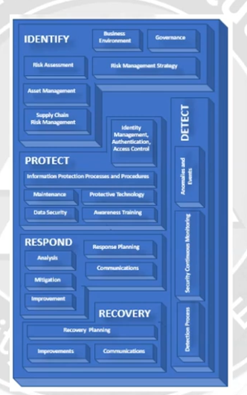

# ASSET MANAGEMENT

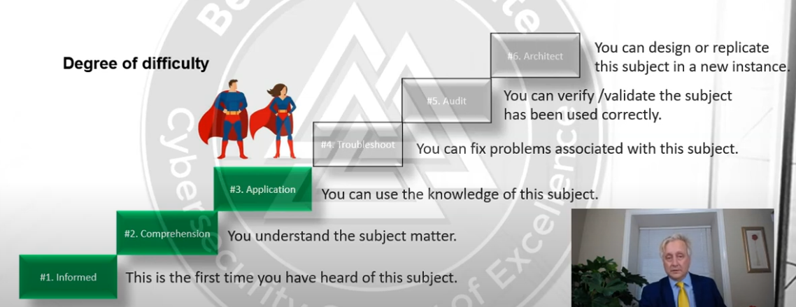

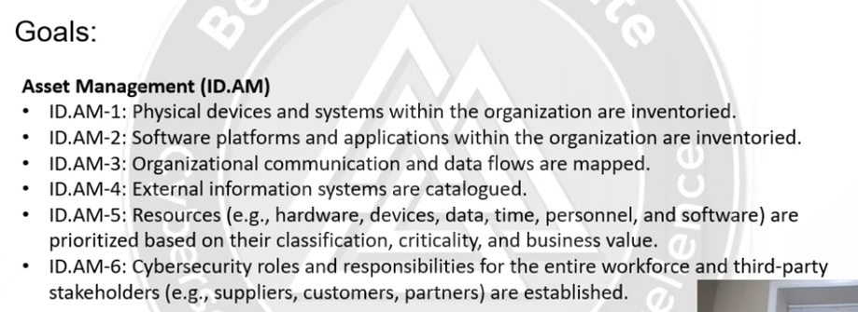

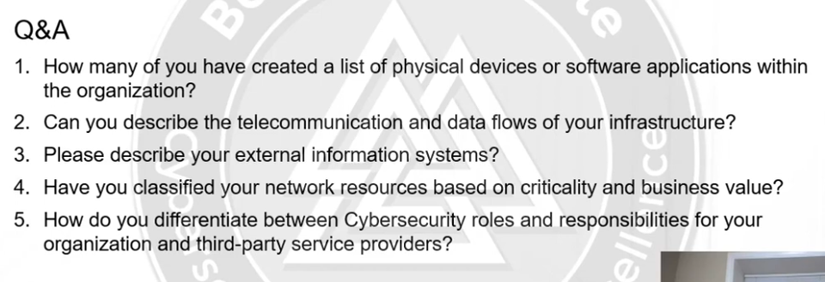

## Assets Classifications:

* Data (most important)
* People
* Softwares:
  + Enterprise class
  + Productivity class
  + ERPs
  + Microsoft utilities software (bug report and documentation)

Behind all these are would be the hardware severs, pcs etc. All are distributed into security zones to maintain identity access.   
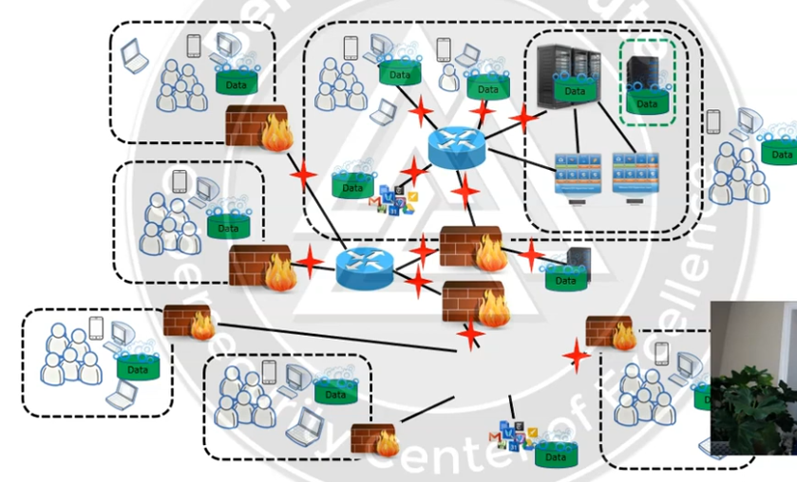

Then we have physical zones (buildings etc.)

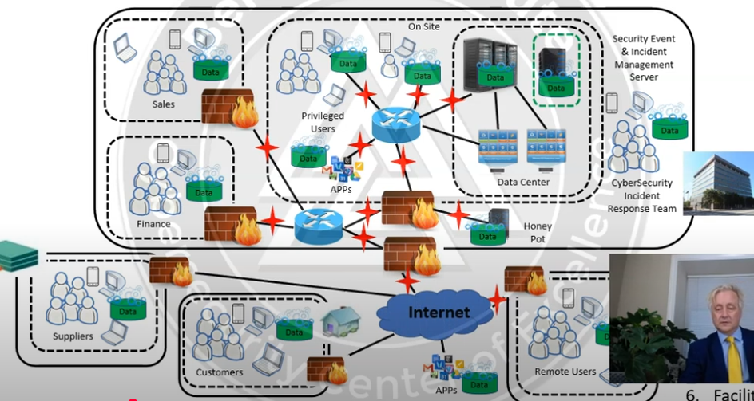

In short there are 6 assets:

1. Data/Information
2. People
3. Software
4. Harware
5. Telecom
6. Facilities

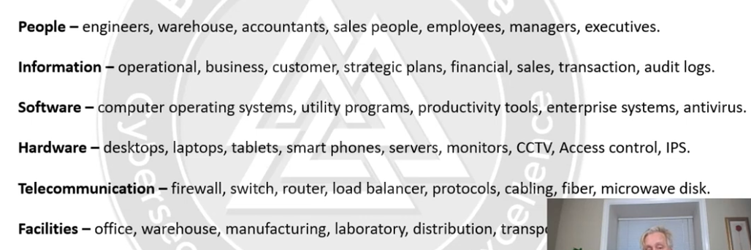

## Answers to q/as

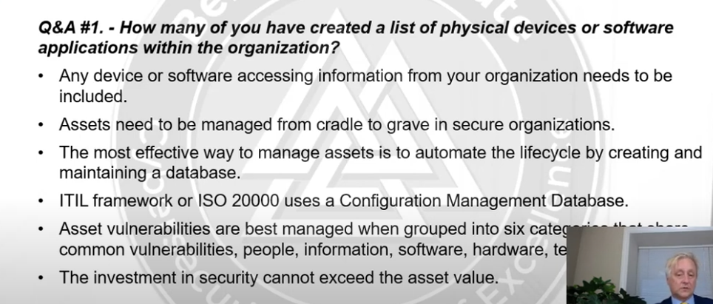

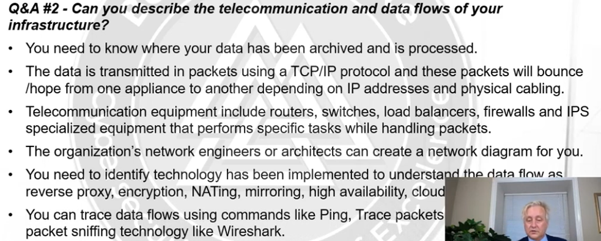

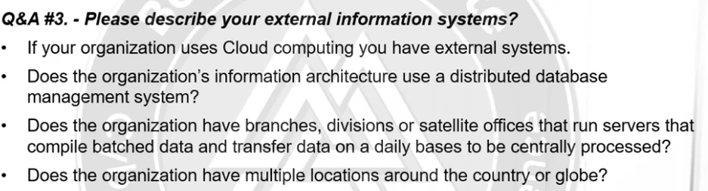

CMDB (configuration management database) for ITIL focuses on asset management.

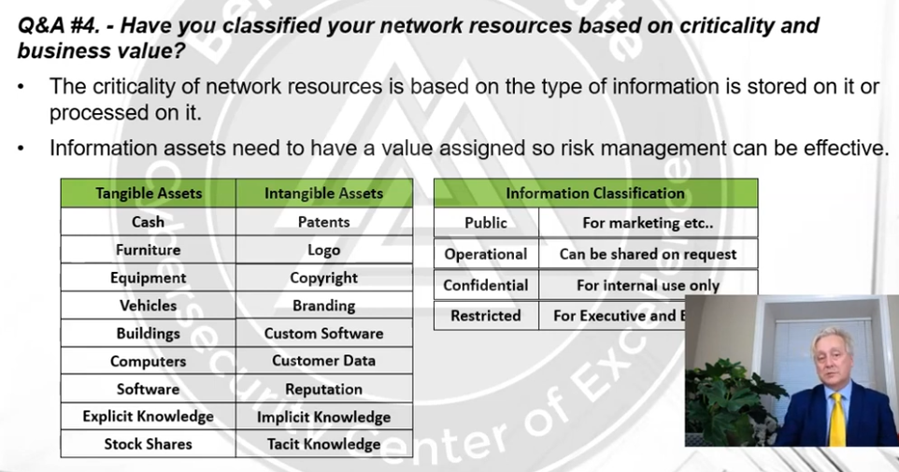

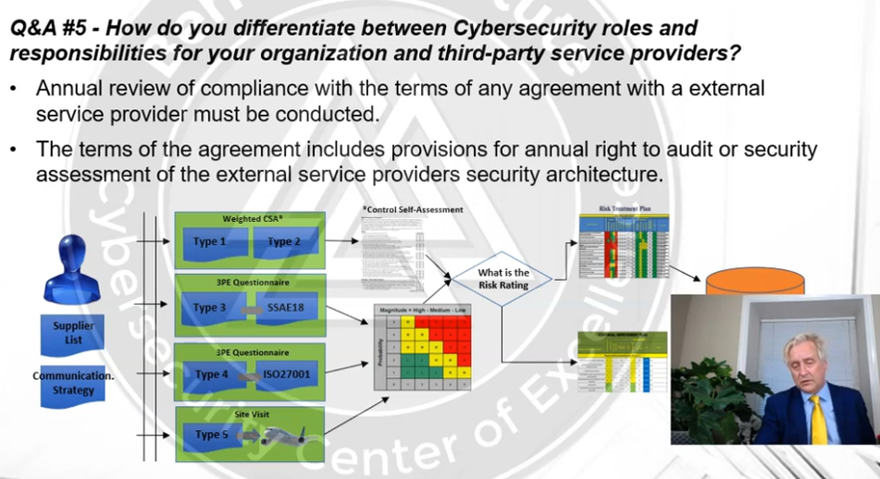

## Practice

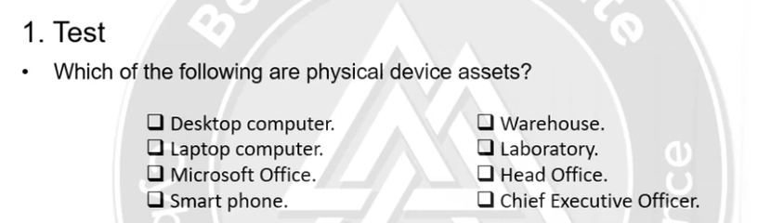

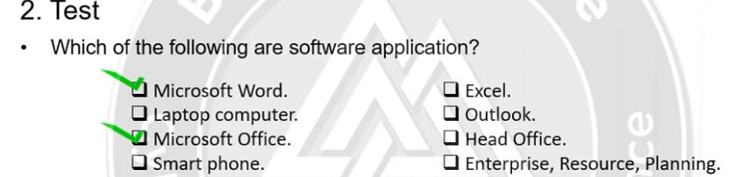

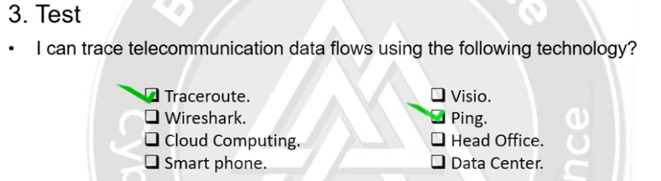

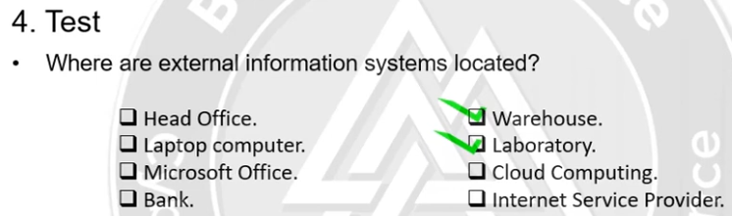

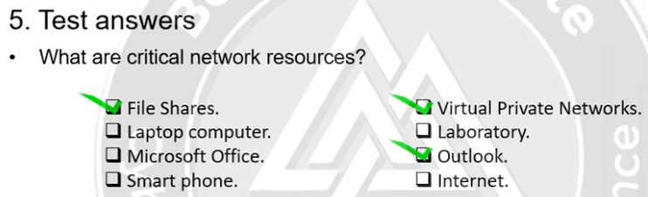

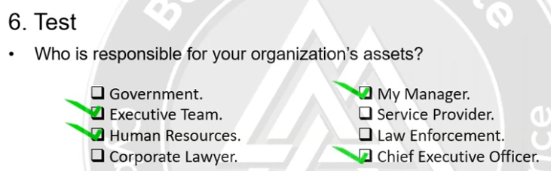

# BUSINESS ENVIRONMENT

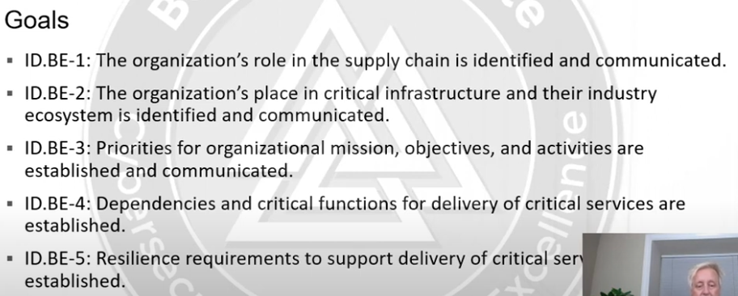

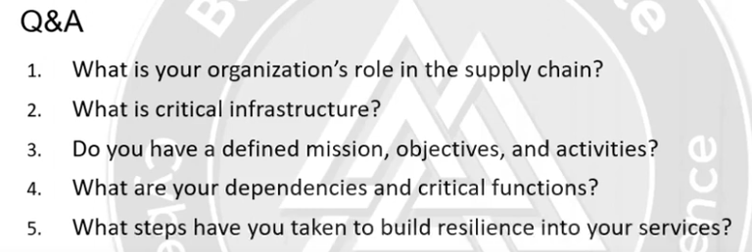

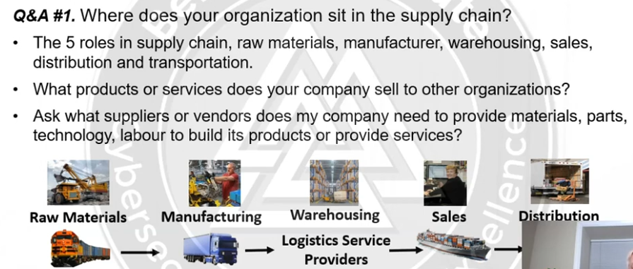

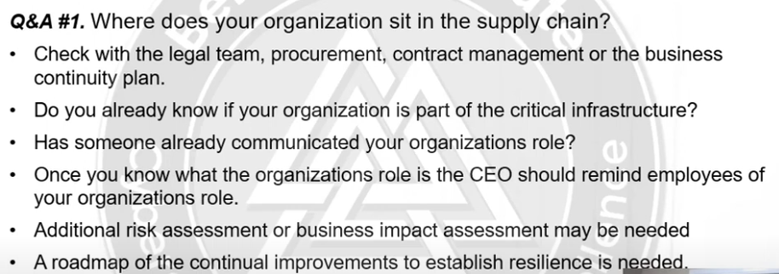

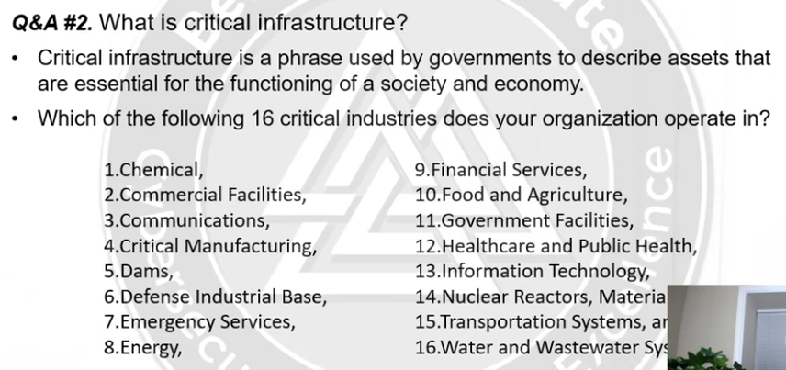

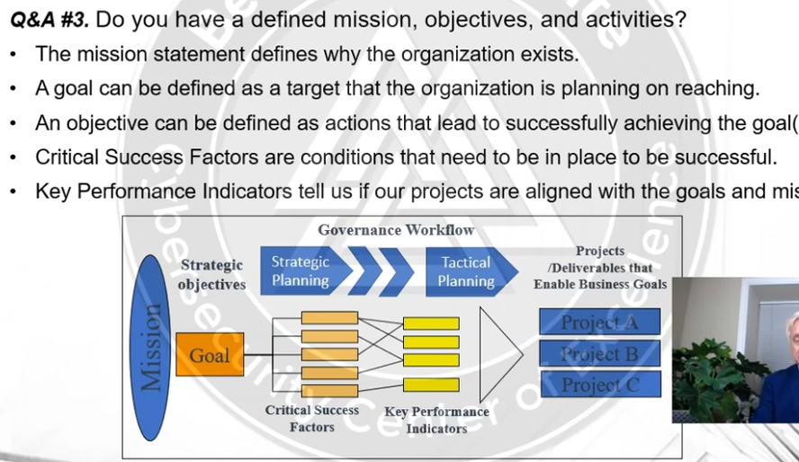

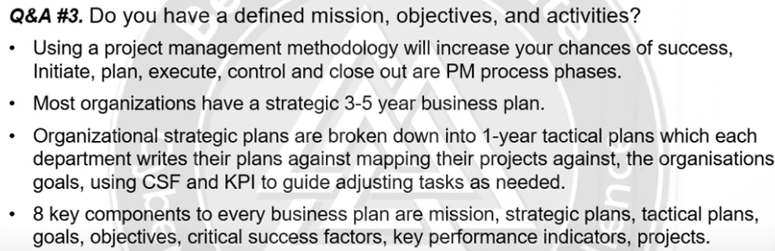

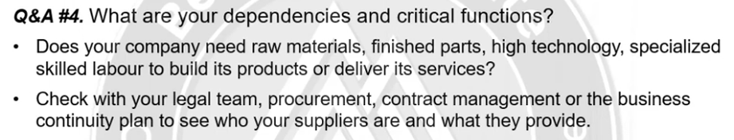

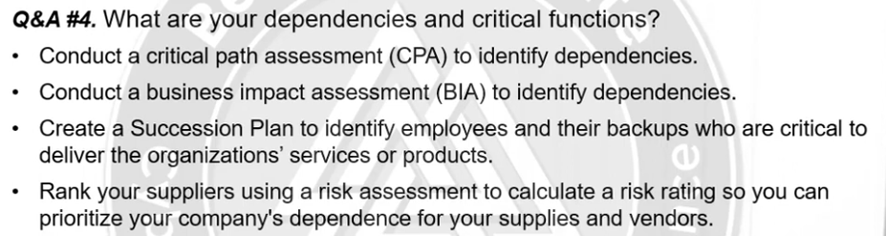

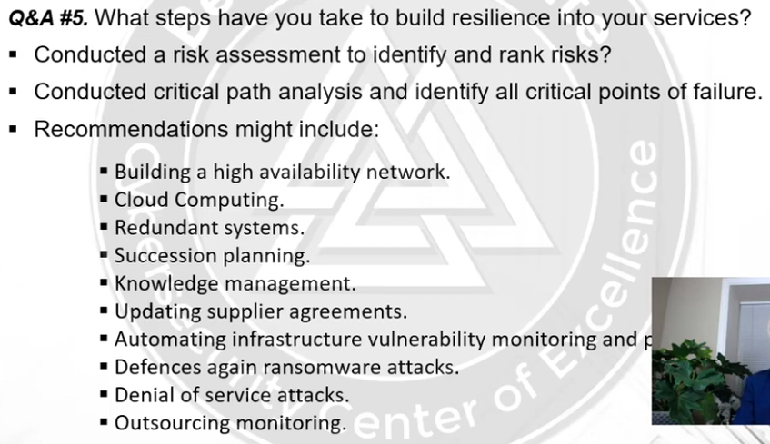

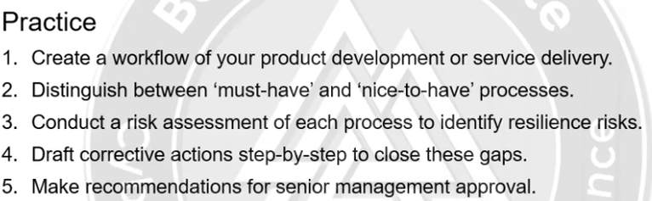

# GOVERNANCE

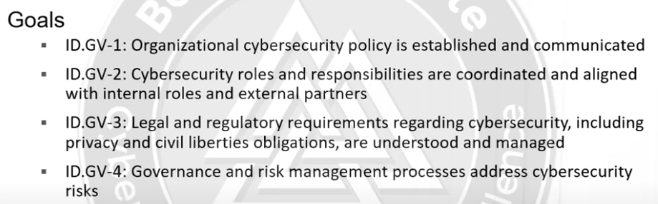

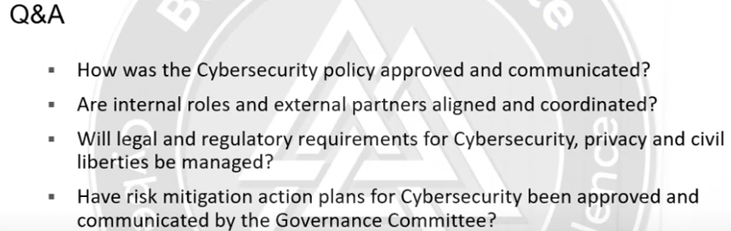

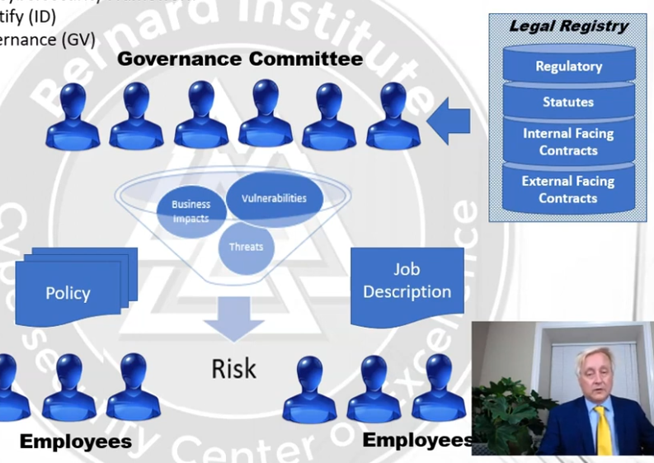

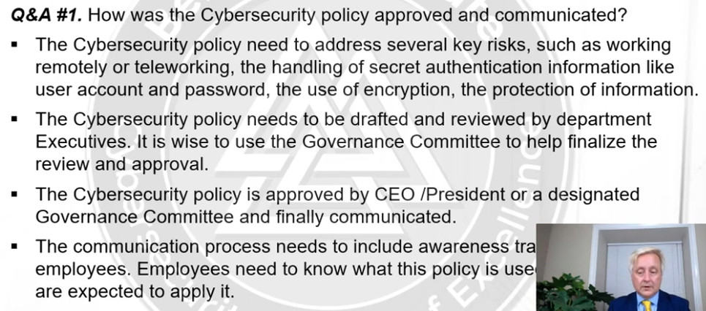

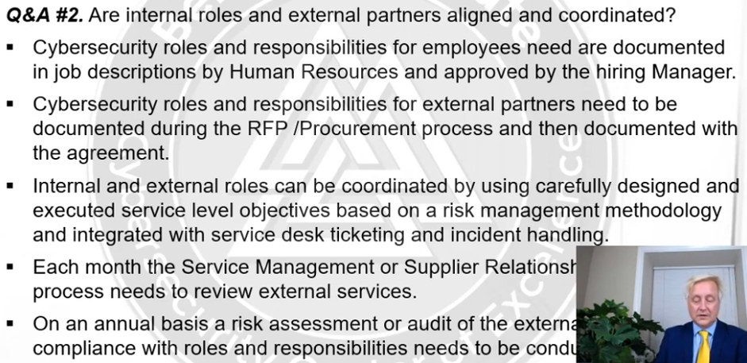

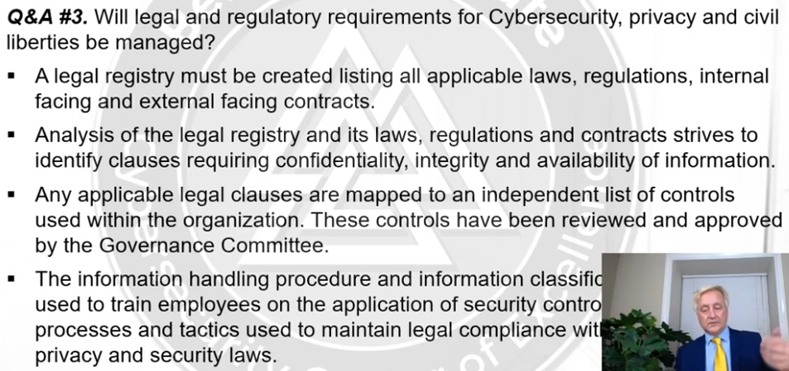

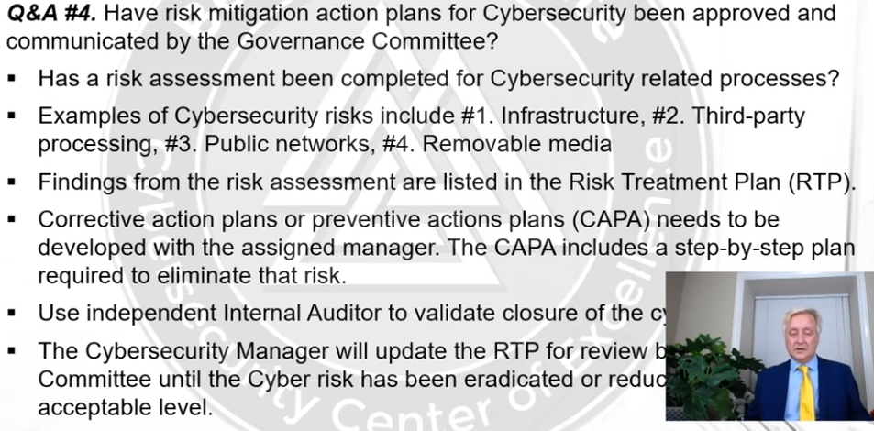

You want to quantify the exposures don’t qualify

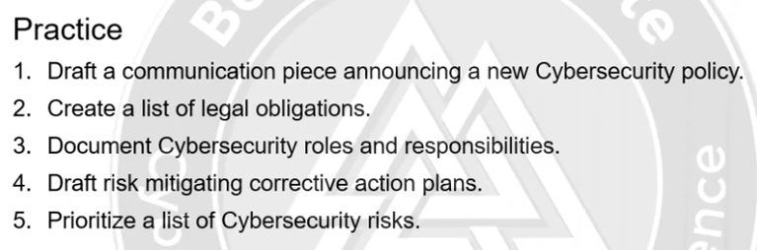

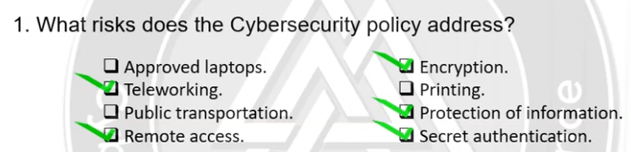

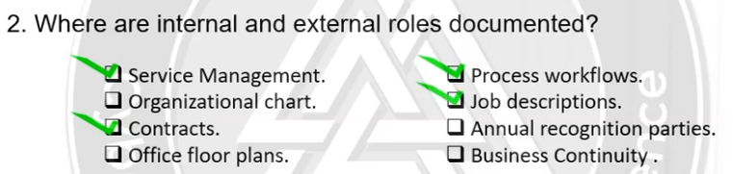

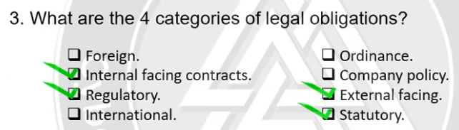

# RISK ASSESSMENT

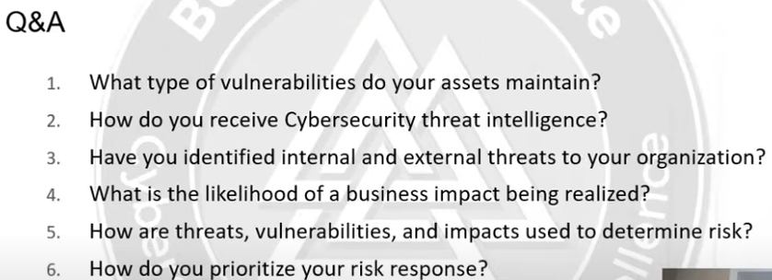

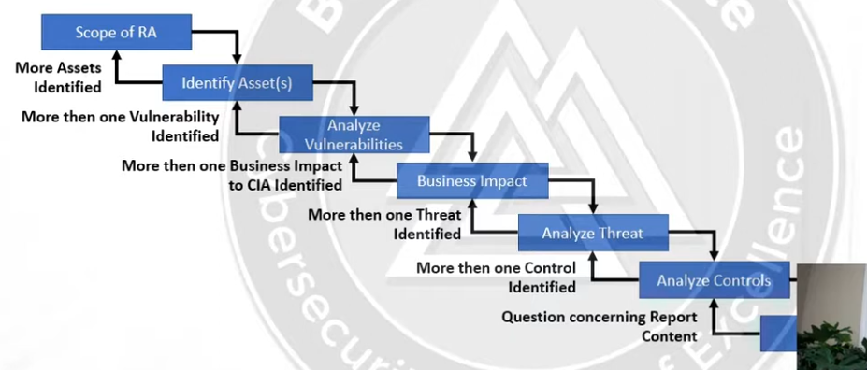

Finally they make a decision to accept, transfer or reject a risk.

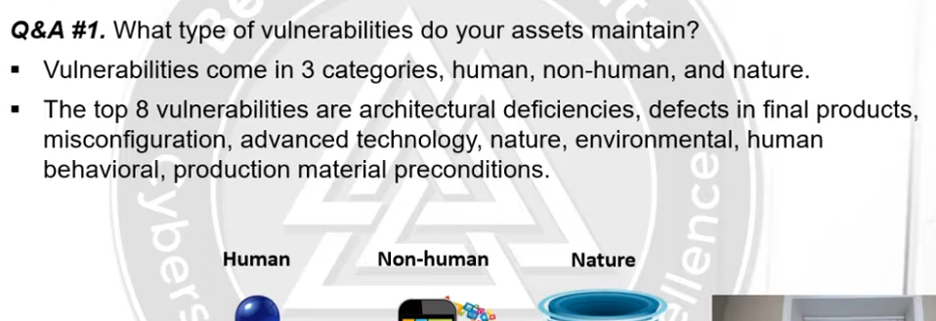

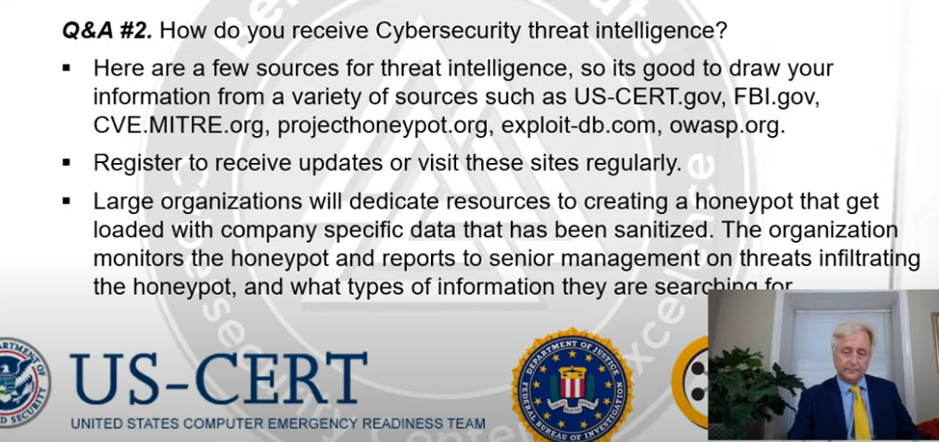

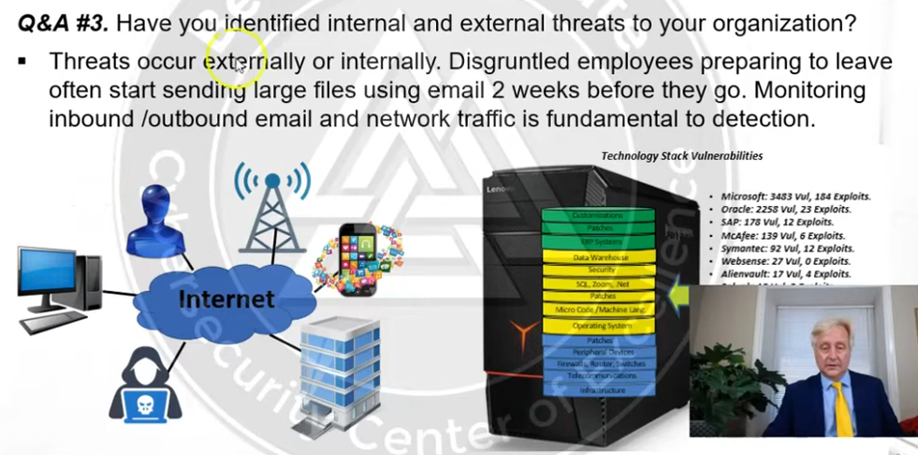

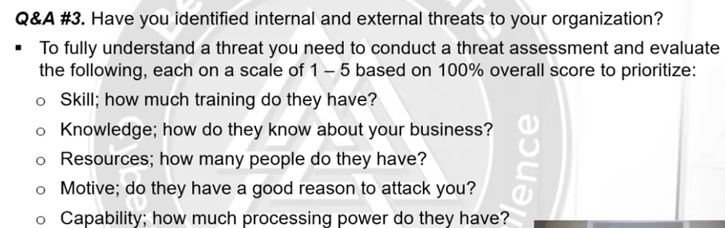

The above is also called threat modelling

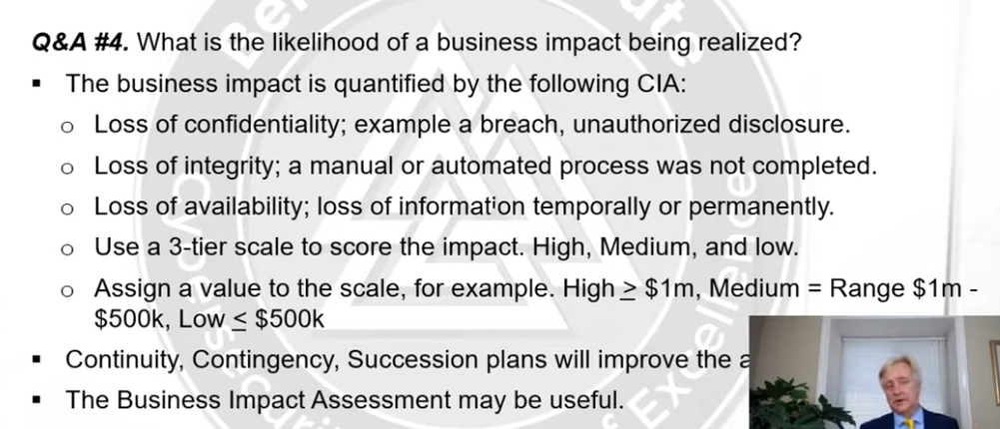

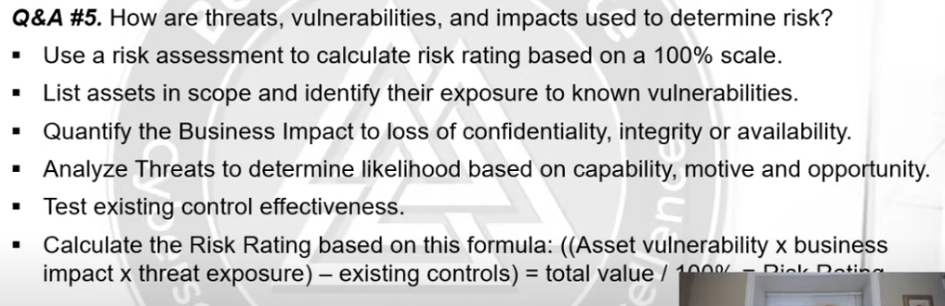

Quantitative risk assessment:

Example of extreme is a zero day attack, example of critical is the vulnerability of our db or server is announced publicly,

80 above gets treated immediately

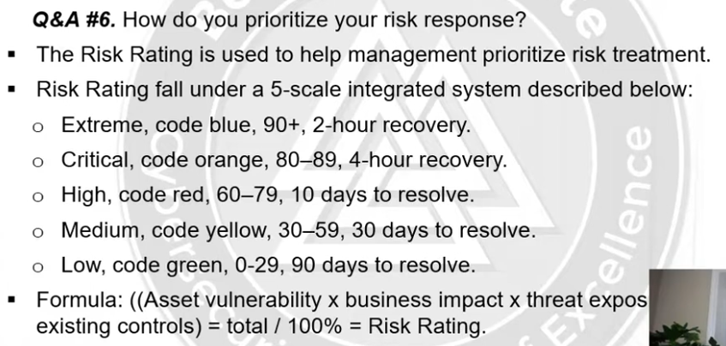

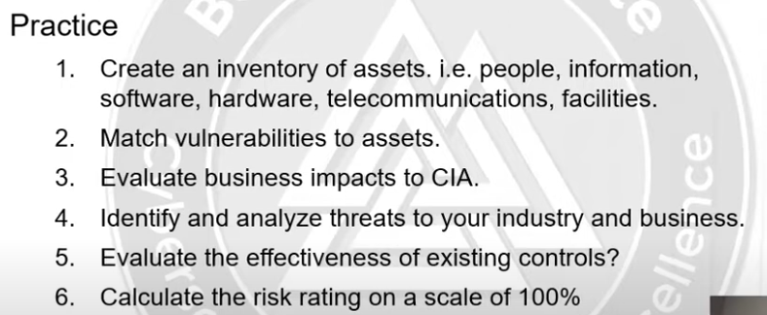

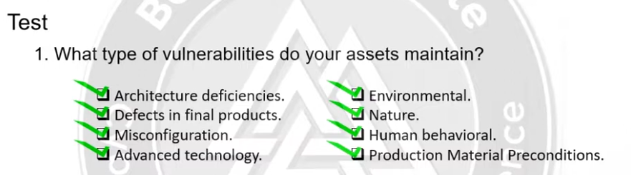

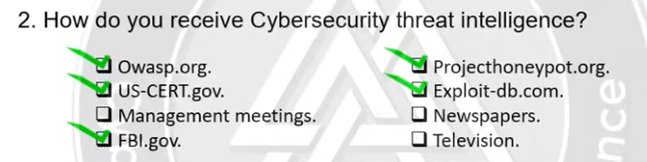

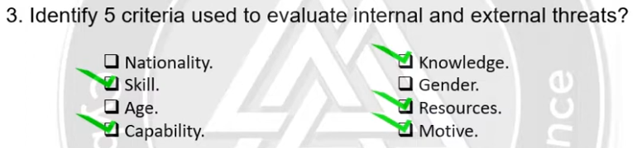

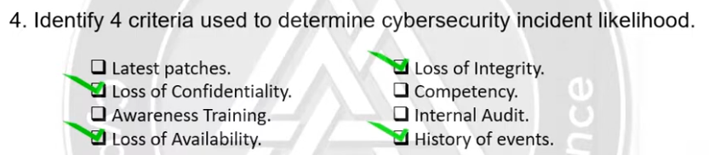

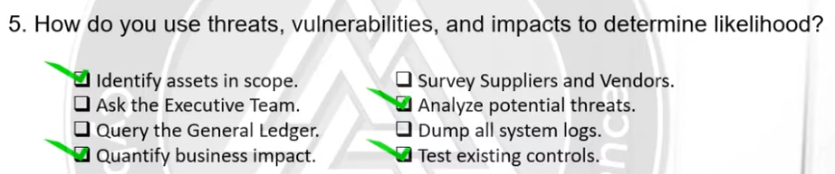

# RISK MANAGEMENT STRATEGIES

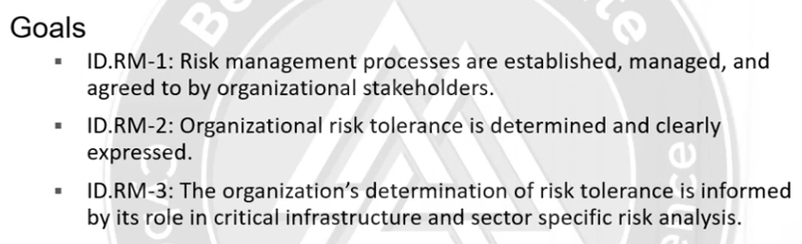

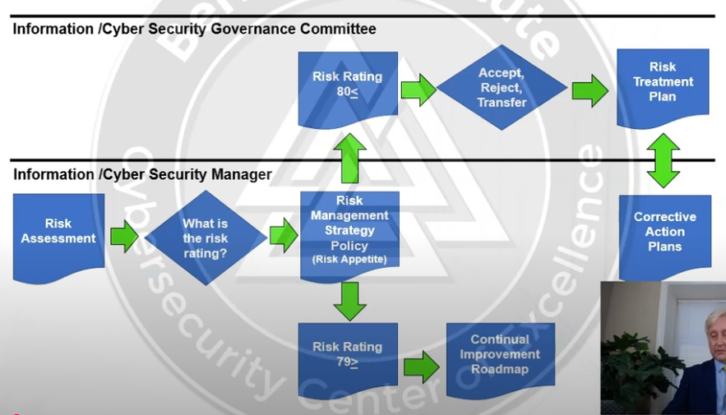

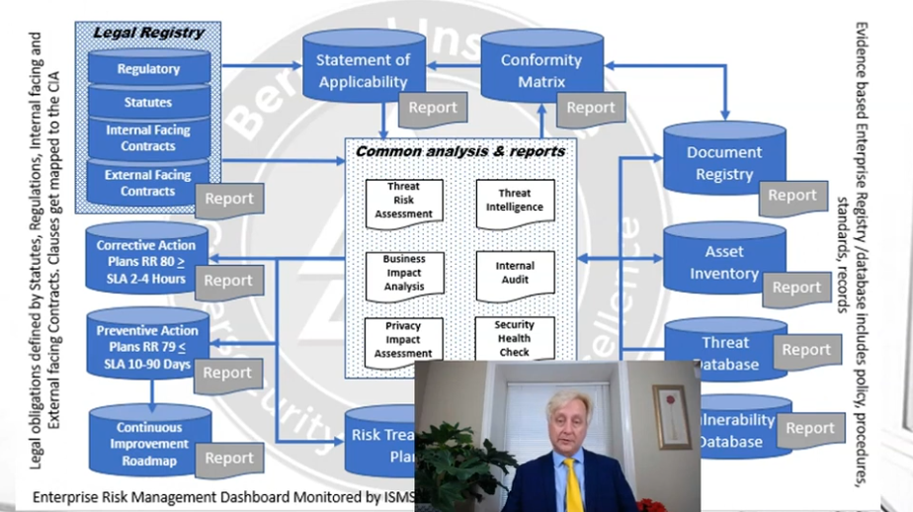

Example of regulatory is pci-dss, status is incorporation act or gdpr act, interna facing contracts products like oracle/Microsoft aggrements, external facing is like aggrements with customer, governments and other externals.

Document registry is archs and orgs to store records and evidences control documents, implicit knowledge is the idea on our mind and when we write that down or document it we convert it to explicit, Conformity matrix comes from quality management in NIST we have 108 conrtol points and map those to policy procedures standards. Vulneribility database mostly related to evaluation process, threat modelling.

Threat intelligence we get be honeypot projects and analysis. Threat risk assessment determines what threats our assets are exposed true, business impact anaylsis tells the impact o f loss of confidentiality.

Risk treatment plan is like a dashboard. Internal audits are quality audits. Privacy Impact Assessment compliance with regulations and statues. PIA is compliance exercise not a risk assessment in risk we see vulnerabilities and assets etc in PIA/compliance we see legislations regulations etc.They do however go hand in hand. Security health checks are done my managers sitting down and reviewing the poliicies.

Statement of applicability is the list of controls that our org has to follow.

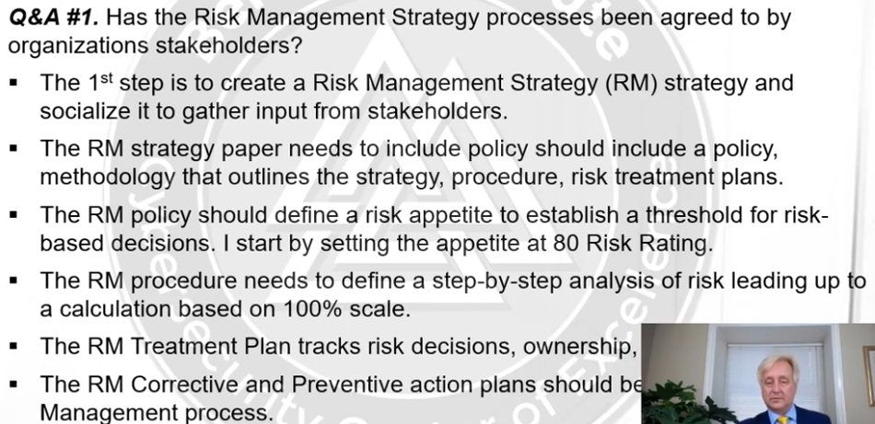

In a enterprise risk management there are 5 risks: financial, strategic, hazard, compliance, and operation risk.

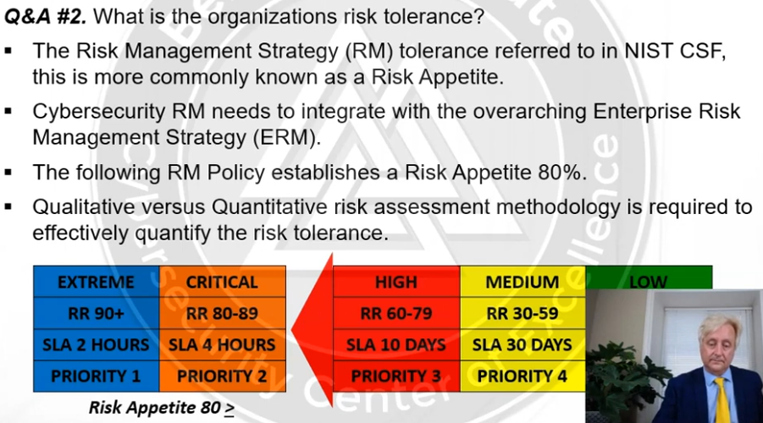

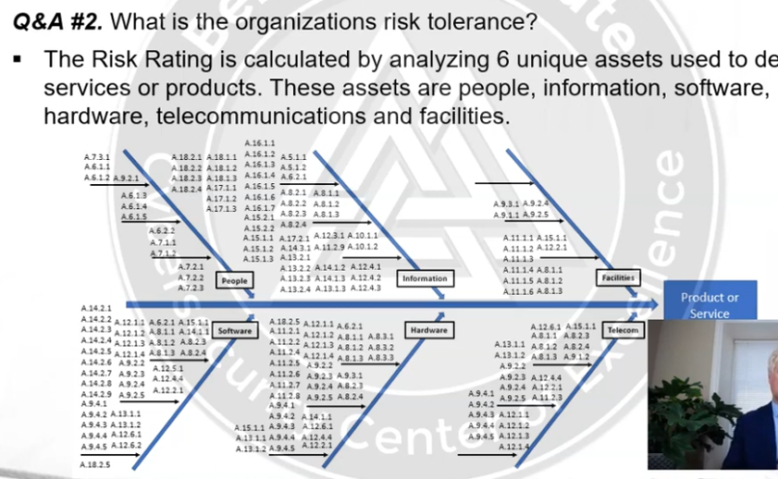

Inside grids are controls from ISO-27001

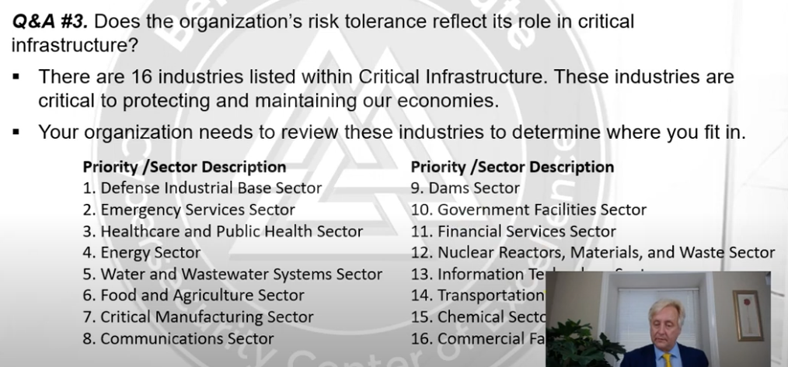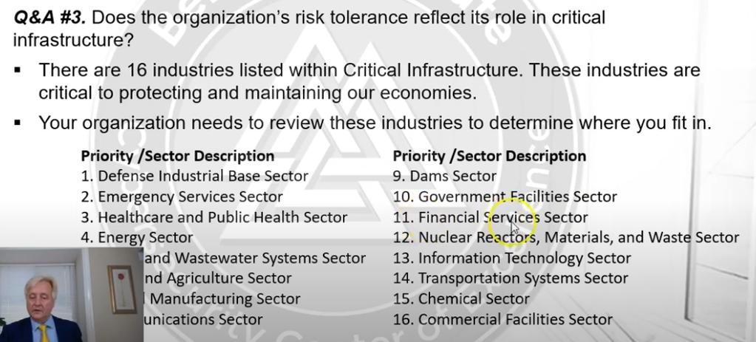

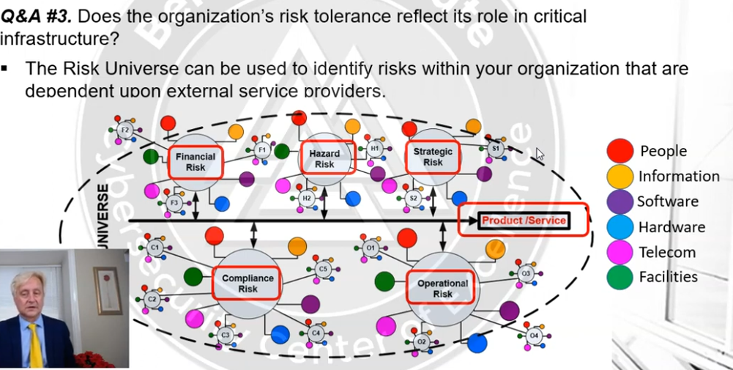

These are from enterprise risk management framework from COSO commission

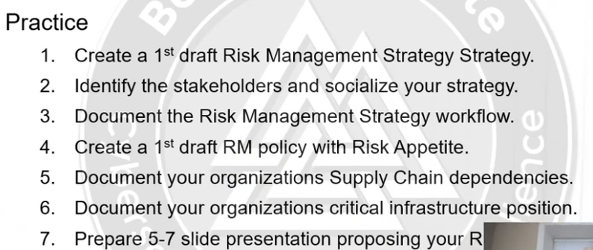

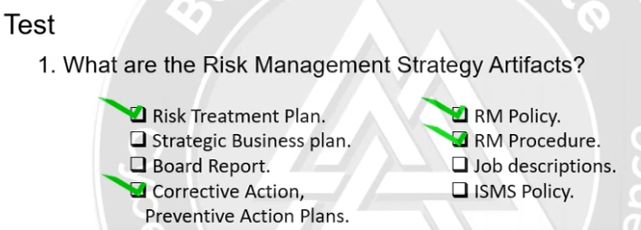

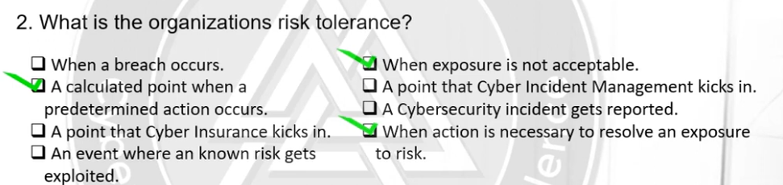

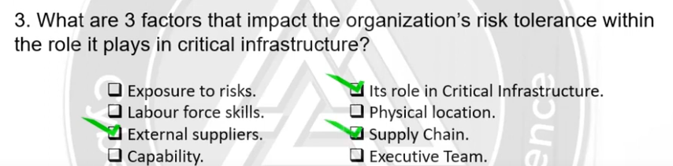

# SUPPLY CHAIN

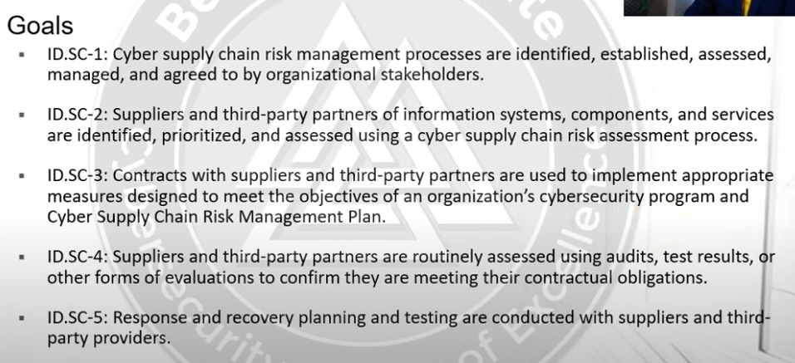

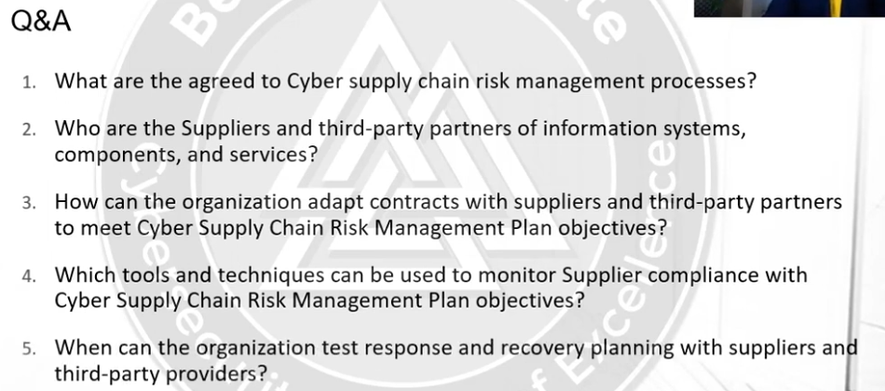

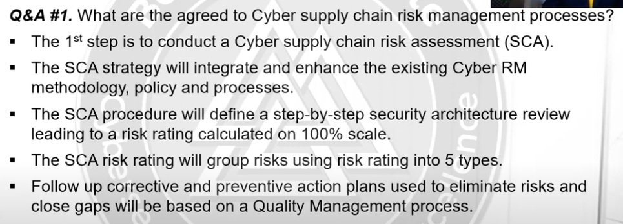

Suppliers could also be brokers

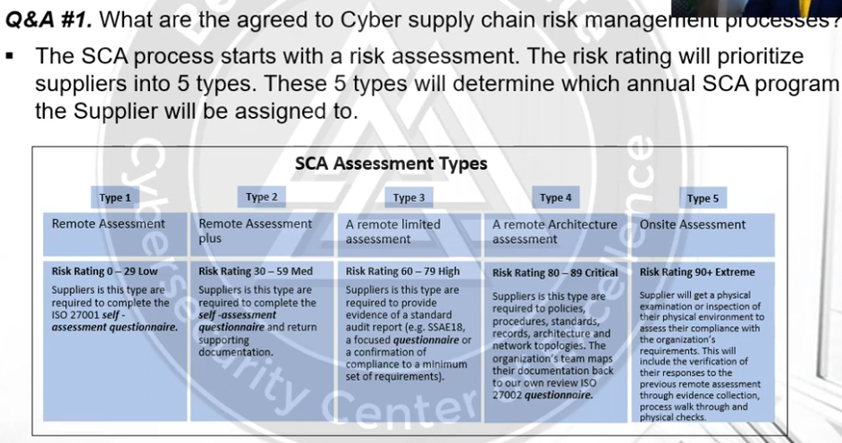

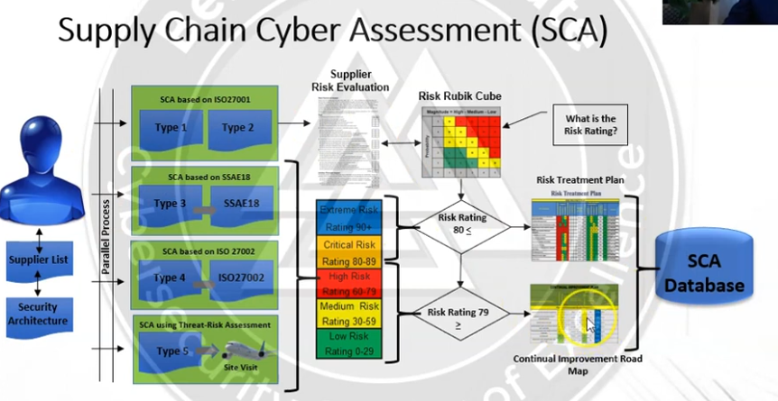

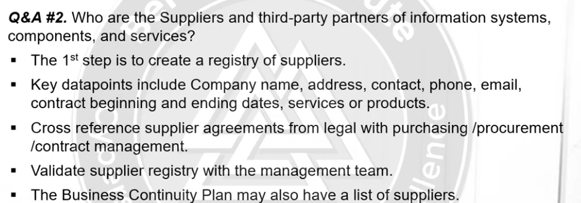

Flowdown clauses are articles that list all controls in process we hand them to suppliers it ensures the contractors that if they are outsourcing a work to a sub-contractor then they must also follow some controls.

